**In The name of GOD**

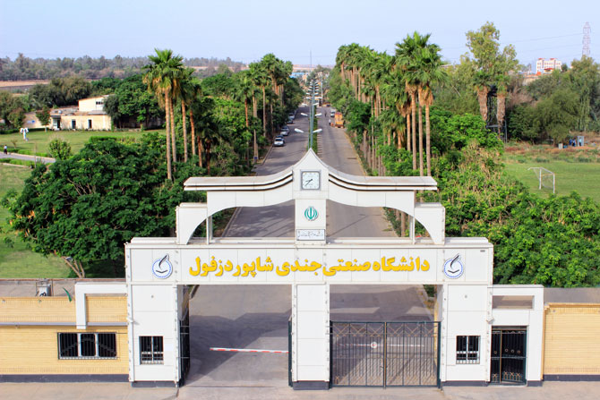

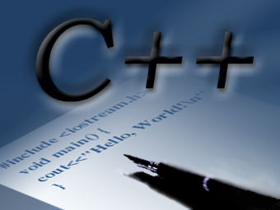

**Title:  Final Project C++ [Source]**

**IDE: C:\Users\Beheshtifar\Desktop\Untitled.png Dev c++**

**professor: Dr. mehdi enayat zare**

**Creator: Reza Beheshti far**